**CH 245: ORGANIC CHEMISTRY 1 LABORATORY (Fall 2019)**

**Title:**

1. **Purpose: (1 point)**

The purpose of this lab is to understand the process of recrystallizing a solid organic compound, in this case, benzoic acid using water. It also introduces some special chemical lab techniques such as gravity filtration and vacuum filtration.

1. **Drawing of structure of the main compound or balanced chemical equation if synthesis is performed: (1 point)**

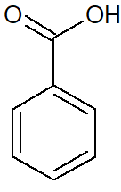 Benzoic Acid

**3. Reagents and the major product (up to 6 points)**

|  |  |  |  |  |  |  |
| --- | --- | --- | --- | --- | --- | --- |
| **Name** | **M.W.**  (0.5 pts) | **Density**  (0.5 pts) | **Amount (grams/mL)**  (0.5 pts) | **Moles**  (0.5 pts) | **Hazards/Precautions**  **(MSDS data) and melting point or boiling point** (2 pts) | **Waste Disposal**  **(aqueous or organic)** (2 pts) |
| Benzoic Acid | 122.12 g/mol | 1.2659 g/cm3 | 0.5g | 0.004 | Skin, eye irritation, M.P. 122.41 °C | Organic |
| Water | 18.01 g/mol | 1 g/cm3 | 15 mL | 0.833 | B.P. 100 °C at 760 mmHg | Aqueous |

**4. Procedure (up to 2 points)**

|  |  |
| --- | --- |
| **Procedure** | **Observations and Lab Data** |
| A summary of the procedure done with bullet points) | Color changes, exothermic or endothermic reactions, gas generation, etc.; tare weights for flasks, etc. |
| * Accurately weigh out 0.5g of benzoic acid and transfer it to a 50 mL Erlenmeyer flask. * Add 12 mL of deionized water. * Add two pieces of boiling stones to the flask. * Place flask on hot stirring plate and heat until benzoic acid dissolves. Occasionally swirl the flask. * While the benzoic acid is dissolving, prepare a fluted filter paper and place it in a warmed funnel. (Warm funnel!) * Place funnel over a beaker when ready to filter. * Hot filter the benzoic acid. * After solution is filtered, cover mouth of beaker containing hot filtrate solution with a watch glass and allow it to cool at room temp. for 10 minutes. * Cool the mixture in an ice bath for 5 minutes. * Filter the mixture using Buchner finnel and vacuum. * Wash the crystals with cold water and press dry with spatula. * Spread crystals on watch glass and allow them to dry. * Weigh the crystals the following week.   Image result for vacuum filtration diagram |  |

**5.** Results; include actual yield in grams and % yield.

0.51g benzoic acid used

0.19g benzoic acid recovered

Recovery (Yield) = 0.19/0.51 * 100 = 37%

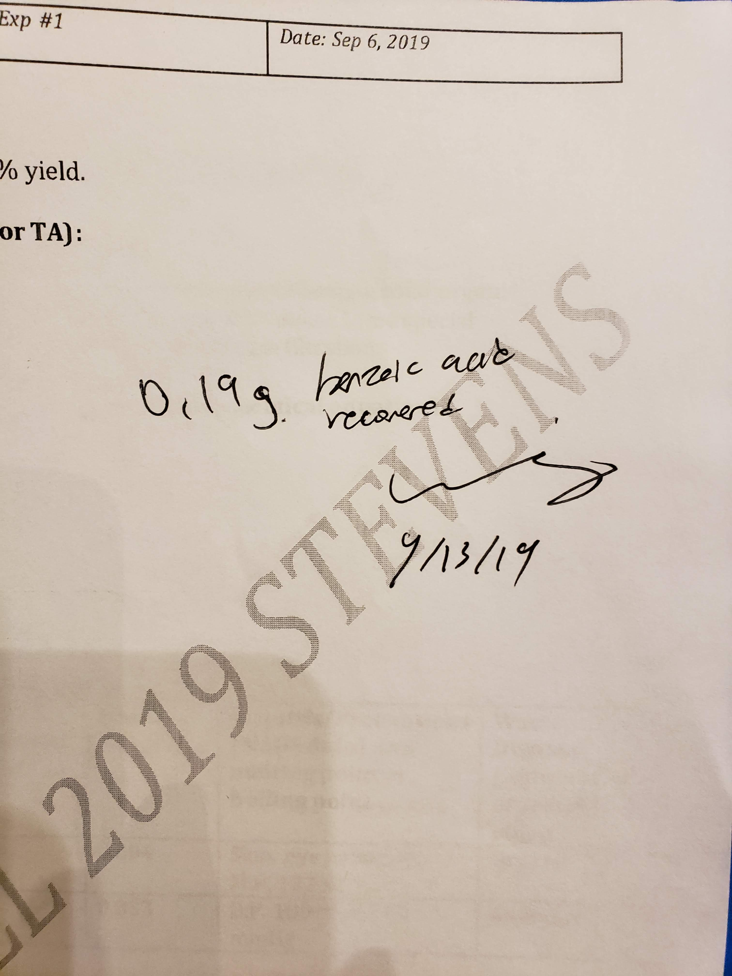

**Results (need to get signed by instructor or TA):**

**6.** Conclusion:

I **accomplished** a recovery of 0.19g benzoic acid (37% recovery) from 0.51g of the original benzoic acid sample, turning a white powder into opaque white needles. During the experiment I **learned** the techniques of hot gravity filtration and vacuum filtration. One **issue** I encountered during the experiment was that the solid crystallized in the neck of the funnel when performing the hot filtration. A small pipette was used to push the crystallized solid down the neck of the funnel, but this likely created some error in the experiment. In the **future,** I think extra time and care should be taken to warm the funnel, as this was likely the biggest source of error. Furthermore, I think using less water to dissolve the acid would yield a better result. The **practical application** of this experiment is to purify organic compounds and the purification of drug molecules.

**7. Postlab Questions**

1. Solubility of benzoic acid (25°C) = 3.4 g/L (Reference 1)

$$40mL water*\frac{1L}{1000mL}*\frac{3.4 g benzoic acid}{1 L water}=0.136g benzoic acid$$

(1.5g benzoic acid – 0.136g benzoic acid dissolved) / 1.5 g benzoic acid = 91% Theoretical Yield

2. A boiling stone is a rock with trapped air inside of it. When the rock is heated, the air inside the rock expands and escapes, creating bubbles in the liquid that prevents overheating the water past boiling point which might cause flash boiling and hot water to spill out of the beaker.

3. I would select solvent B.

**References:**

Reference 1: Benzoic Acid MSDS